**CME: ASSIGNMENT: 4**

**Q1. Question 1: Provide the plots for each of your RAxML best trees with node support values. Be sure to clearly label which tree corresponds to each gene. Describe any differences in the clades that you observe between the 2 trees: do the lizards and snakes form distinct, separate clades in each tree? Do you see any polytomies in either tree? In each tree, which node has the lowest bootstrap support**

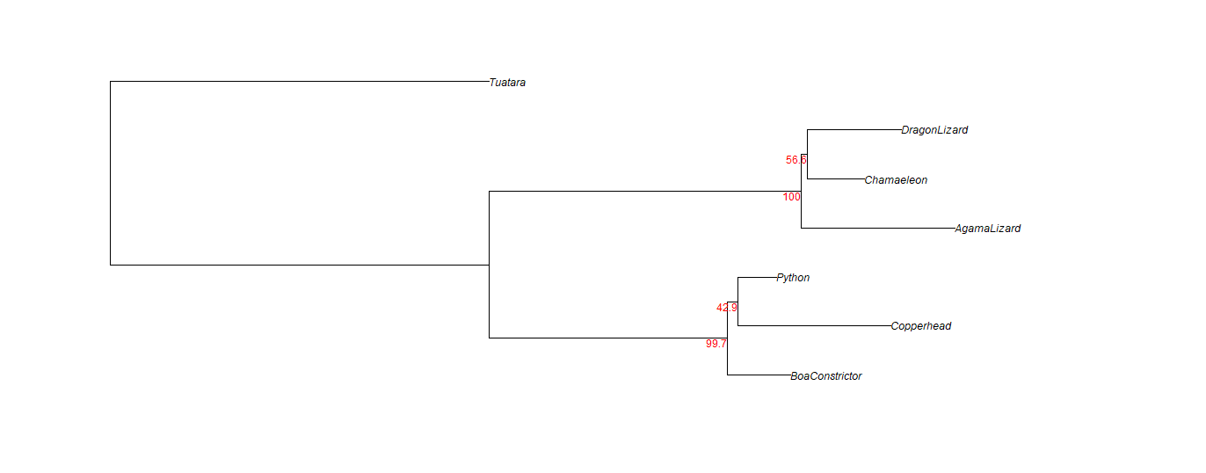

Fig: 1A, Best tree with bootstrap value for R35-reptiles gene

The figures 1A and 1B show the best trees with the bootstrap values for R35-reptiles gene and SLC8A1-reptiles gene respectively. The main difference that we observe in both the trees is the arrangement of species in clades. In Fig 1A, the lizards and snakes are grouped in different clades while in Fig 1B, for gene SLC8A1, it is not the same. Here the clades are different. DragonLizard is closer to Chamaeleon in case of R35-reptile gene but in 1B we can see it closer to the Copperhead which is a snake species. We can see polytomy in 1B for SLC8A1-reptiles gene where snakes fall in that clade.

The lowest bootstrap value for the R35-reptile tree is at the base of Python and Copperhead; 42.9 and that for the SLC8A1 tree is 26.6 at the base of the first division after Tuatara is separated, i.e at the first node.

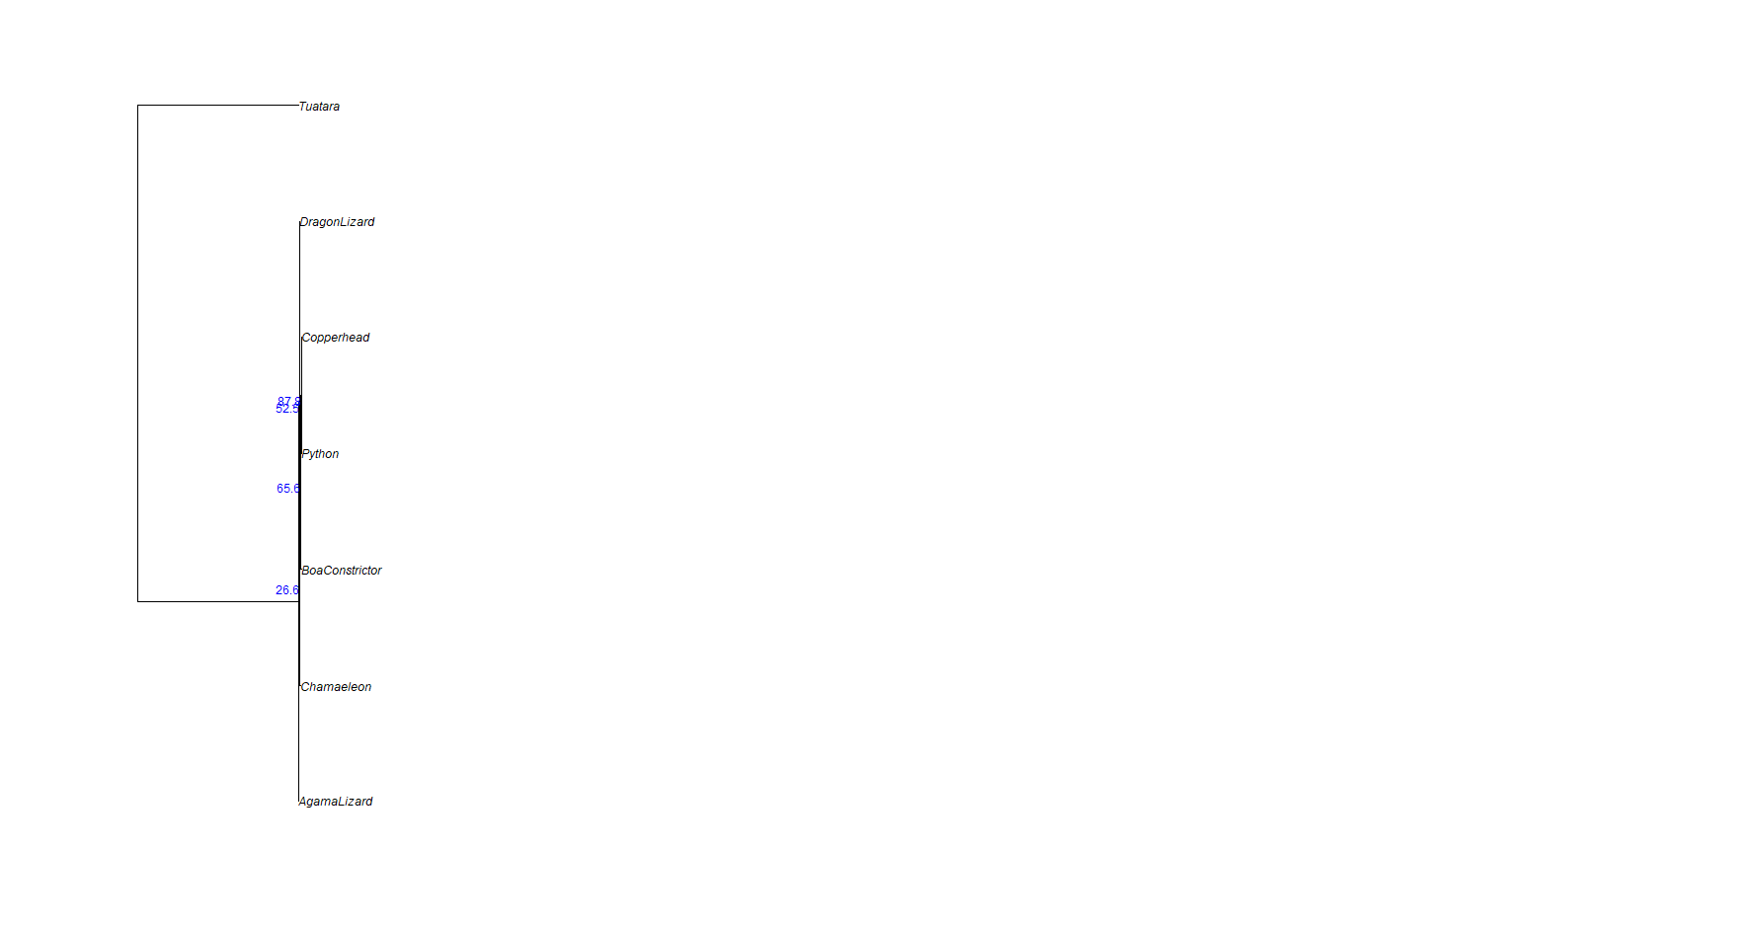

Fig: 1B, Best tree with bootstrap value for SLC8A1-reptiles gene

**Question 2: What is the symmetric difference, branch score difference, and path difference between your two trees? Which number implies the biggest difference in the trees? Based on what you know about the definition of these metrics, why would one score be much higher than the others? Does your highest score make sense given what you see when you plot the two trees?**

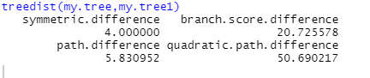

Fig 2

The symmetric difference, branch score difference, and path difference between your two trees are 4.0, 20.72 and 5.83 respectively. The number that implies the biggest difference is the quadratic path

difference which is 50.69 here. The symmetric difference means sum of the number of clades unique to each tree in a comparison, branch score difference means square root of the sum of the squared differences between all of the branch lengths in two trees, and path difference > the # edges that have to be crossed between all pairs of tips; calculate the difference in this # for 2 trees square root of the sum of squared differences. In case of quadratic path difference, it is more or less similar to the path difference but instead uses the branch lengths instead of just the number of branches between taxa, which is why the score is higher than other parameters.

**Q3. Provide a plot of your best tree with bootstrap support values. Describe where the legless lizards appear on the tree in relation to the regular, 4-legged lizard species.**

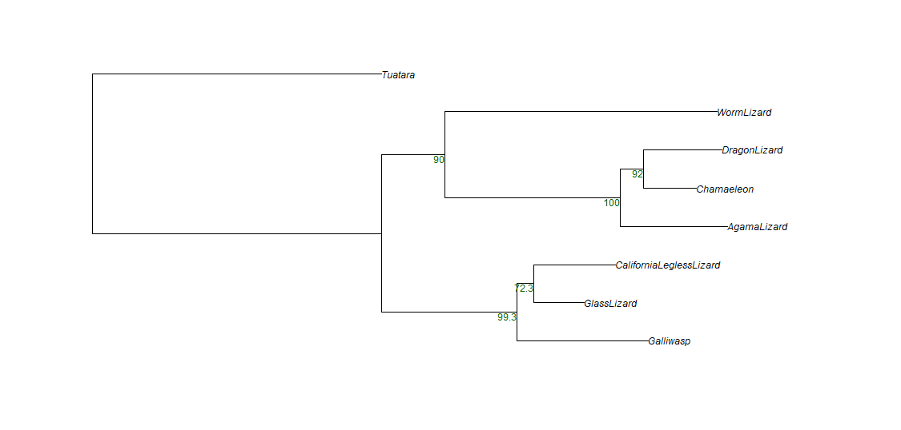

Fig: 3, Best tree with bootstrap value for R35-Lizards gene

The tree with the gene R35 -lizards also has the Tuatara as the outgroup species. The legless lizards (California legless lizard) is forming a clade with Glass Lizard which in turn forms a clade with Galliwasp. The other 4-legged lizards are under the other parent clade though legless lizard remains in almost the middle of the tree and not on any extremes (not much far away from the legged lizards).

**Q4. Provide the plot of your strict consensus tree. Do you retain any phylogenetic information in this tree, or did all of the nodes turn into polytomies?**

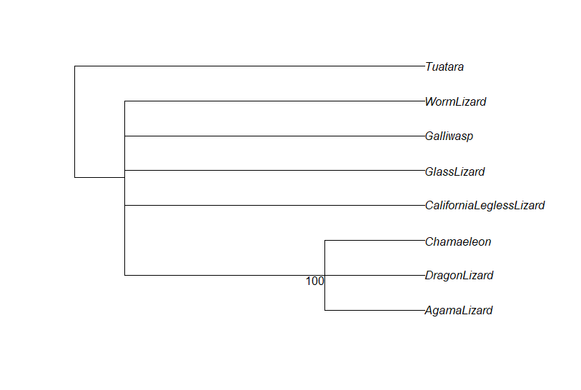

Fig: 4, Strict Consensus Tree

Here, we can see that we have a polytomic tree even though the clades are different.

Q5. Provide the plot of your majority rule consensus tree. Do you get back all of the phylogenetic information you lost in the strict consensus tree, or are there still polytomies?

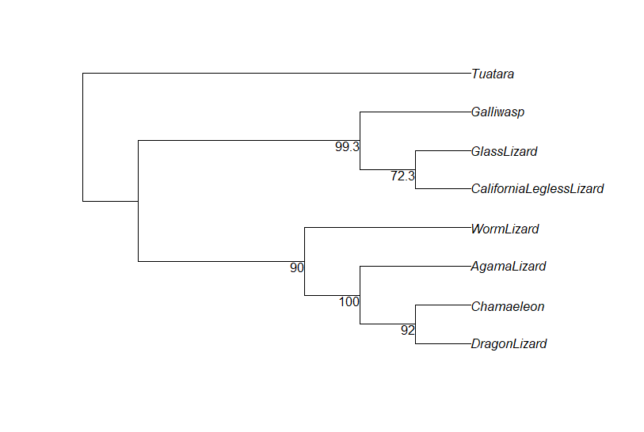

Fig: 5, Majority Rule Consensus Tree

This tree does not have the polytomic nature and brings the phylogenetic information back.

Q6. Provide the plot of your maximum clade credibility tree.

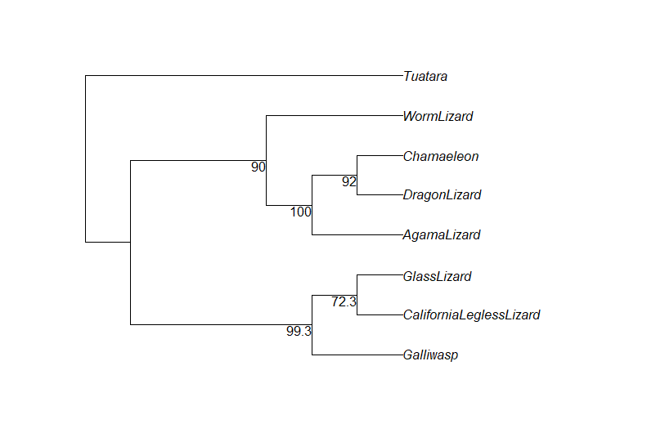

Fig: 6, maximum clade credibility tree

Q7. Provide the plot of your average tree. Do any of the clades or relationships change when compared to your maximum clade credibility tree?

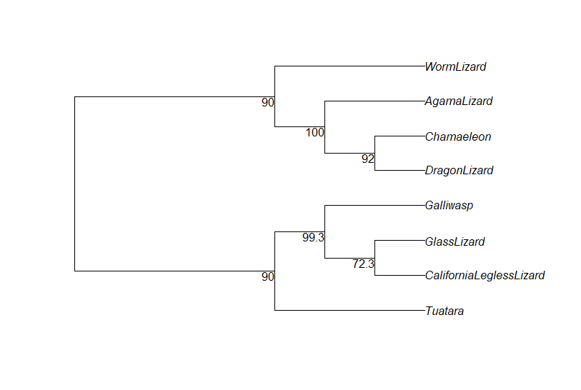

Fig: 7, Average tree

When compared to the MCC, the clades do change in arrangement but not within the clades. The bootstrap score remains the same.

Q8. Provide the plot of your agreement subtree. Which taxa are included in this tree?

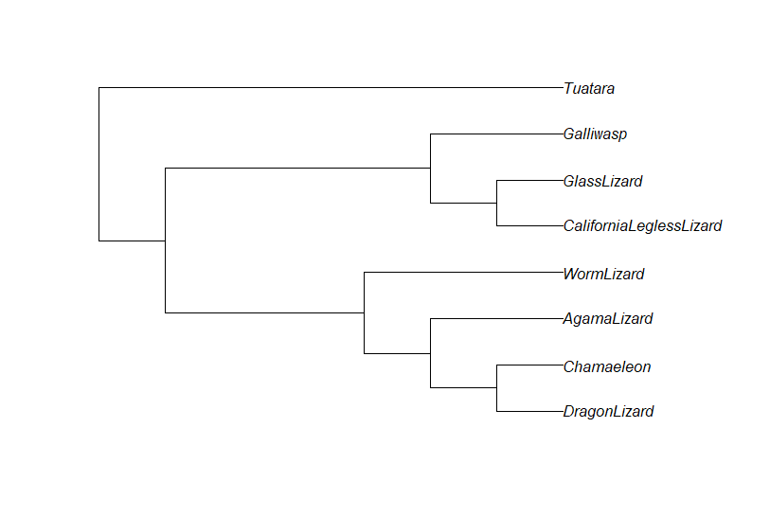

Fig: 8, Agreement subtree

Here, we are plotting information regarding the legless and 4-legged lizards and comparing them. The clades are also similar to the best trees.

Q9. Provide the plot of your combined super tree. Looking at where your legless lizards end up on this tree, how many times do you think "leglessness" evolved?

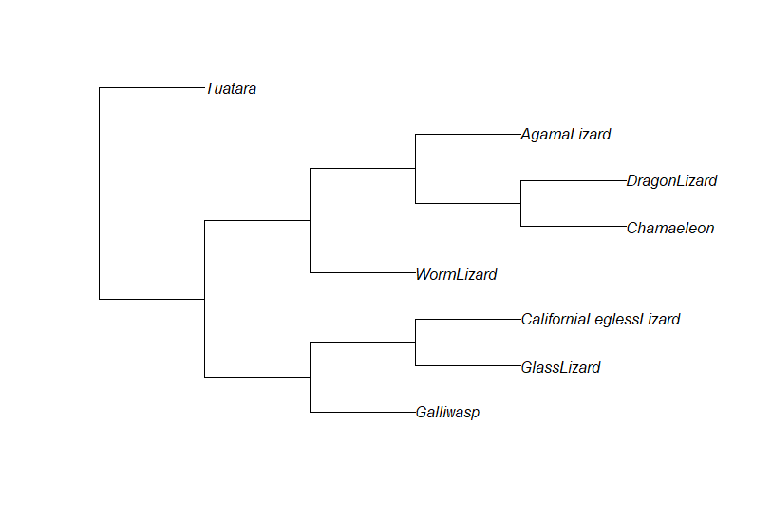

Fig: 9, Supertree

The California legless lizard is evolving 3 times in the course of time as we can see the figure.